Hospital Emergency Room Dashboard Report

Introduction
In this project, I created a Hospital Emergency Room Dashboard in Microsoft Excel to analyze patient data and emergency room performance. The main objective of this dashboard is to understand patient flow, waiting time, satisfaction level, and referral trends.

Overview of the Dashboard
This dashboard focuses on the year 2023 and 2024, and it allows filtering by months using slicers. It provides important insights related to patient count, waiting time, age distribution, gender ratio, and department referrals.

KPI

1. Total Number of Patients
The total number of patients recorded is 9,216.

This shows the overall patient load handled by the emergency department.

2. Average Waiting Time
The average waiting time is 35.26 minutes.
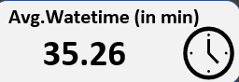s
This helps in evaluating how efficiently patients are being attended. Reducing waiting time can improve patient satisfaction.

3. Patient Satisfaction Score

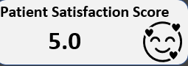
The satisfaction score is 5.0, which indicates that patients are generally satisfied with the emergency services provided.

Detailed Analysis

1. Admission Status
- Admitted: 4,612 patients (50.04%)
- Not Admitted: 4,604 patients (49.96%)
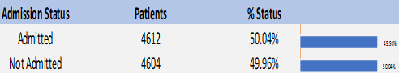
This shows that approximately half of the patients required hospital admission, while the other half were treated and discharged.

2. Patients Attend Within Time

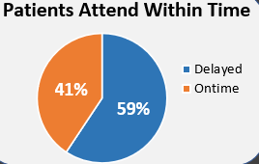
- 59% of patients were delayed
- 41% were attended on time
This indicates that more than half of the patients experienced delays, which can be an area of improvement for hospital management.

3. Patients by Age Group
The highest number of patients falls under the 40–49 age group (2284 patients).
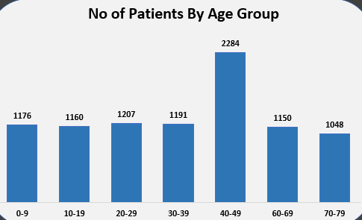
Other age groups show relatively balanced distribution. This analysis helps in understanding which age segment requires more emergency services.

4. Patients by Gender
- Male: 51%
- Female: 49%
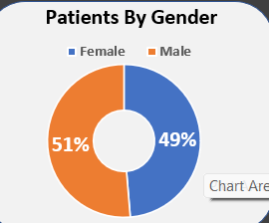
This shows that male and female patients are almost equally distributed, with a slightly higher percentage of male patients.

5. Patients by Department Referral
Most patients did not require a department referral (5400 cases).
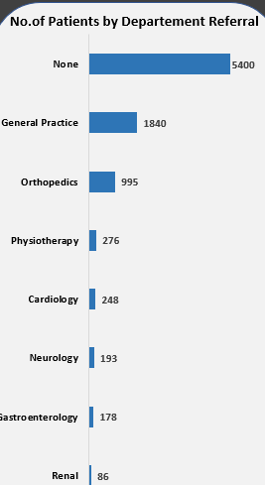
Among referred departments:
- General Practice has the highest referrals.
- Orthopedics also has a significant number of cases.
- Other departments like Cardiology, Neurology, and Renal have comparatively fewer cases.
This helps the hospital understand which departments receive more emergency referrals.

Tools & Techniques Used
- Microsoft Excel
- Power Pivot
- Pivot Tables
- Pivot Charts
- Slicers for month and year filtering
- KPI Cards
- Data Cleaning and Formatting

Conclusion
This dashboard provides a clear and interactive view of emergency room performance. It helps in:
- Monitoring patient flow
- Identifying waiting time issues
- Understanding age and gender distribution
- Tracking department referrals
- Analyzing admission rates

